|  |
| --- |
|  |
| Thirst of Man Web App Design |
| Comp 4711 Assignment 2 |
|  |
| **Mateusz Siwoski & Jordan Marling** |
| **3/9/2014** |

|  |
| --- |
|  |

Table of Contents

Modification: 2

Notes: 2

Introduction: 2

Audience: 2

Goals and Strategy: 2

Categories: 3

Wireframe: 4

Webpage Mockup: 4

Database Design: 5

**Team: O01 By Jordan Marling and Mateusz Siwoski**

## Modification:

Since assignment 1, we have done a few modifications and additions.

* Updated the database to be better organized, adding many additional files
* Added rotating quotes throughout the site
* Added Profiles for the bloggers
* Added an Events Calendar
* Added Post Management capabilities using CKEditor
* Added User Management/Roles
* Added Image Uploading to the website using KCFinder
* Added Pagination, Categories, Featured Blogs and Archives
* Added the use of the Kube CSS Framework
* Added the Trends table

## Notes:

We have found that when using the image uploader, there would be consistent errors when using Google Chrome. Users should be using Firefox for all image uploading.

## Introduction:

The purpose of our blog is to speak about the local craft beer market in Vancouver and review the beers produced. Each review consists of a description of the beer, the taste, colour and pour of the beer and what we thought about the beer overall. There will be additional information regarding the beer such as the brewer, the purchased location and a brief history on the type of beer. Our rating system will be broken down by the Colour, Pour and the Taste and complexity of the beer. The final score will be the overall feel for the beer. The score will be a decision of either Never Again, Socially, Consistently Delicious and I would go out of my way.

## Audience:

Our target audience are beer drinkers. More specifically, craft beer drinkers in Vancouver and BC. This is why our review system works the way it does, as the beers will be found either in the local BC Liquor Store or being distributed by a local brewer in BC. As well, with our section on recipes, we hope to not only have people interested in beer, but how they can use it in their day to day cooking.

## Goals and Strategy:

Our posts reflect our tastes of the local beer market, and how that beer affects the local restaurant scene. Our posts will primarily cover beer, however, they will also include such posts as recipes of meals that were enjoyed or created with the beer. As beer drinkers ourselves, we understand that with such a huge increase in the local scene, it can be very difficult to make up your mind on what to drink, and since we do enjoy beer, we thought it would be important to share our take.

We hope that the site will be used as a decision maker when looking at something new to try. Our posts are open and honest and we will not be prejudice to any brand or type. We want to be as neutral to our opinions.

We plan on allowing the website to have additional posts by other users, and possibly having commentary added.

## Categories:

The keywords we want to target are words that reflect the local brewery scene: Vancouver Beer, Parallel 49, Four Winds, main street beer, cheap happy hour Vancouver, best beer Vancouver bar, Vancouver craft beer

## Wireframe:

This is an example of the wireframe for our landing page:

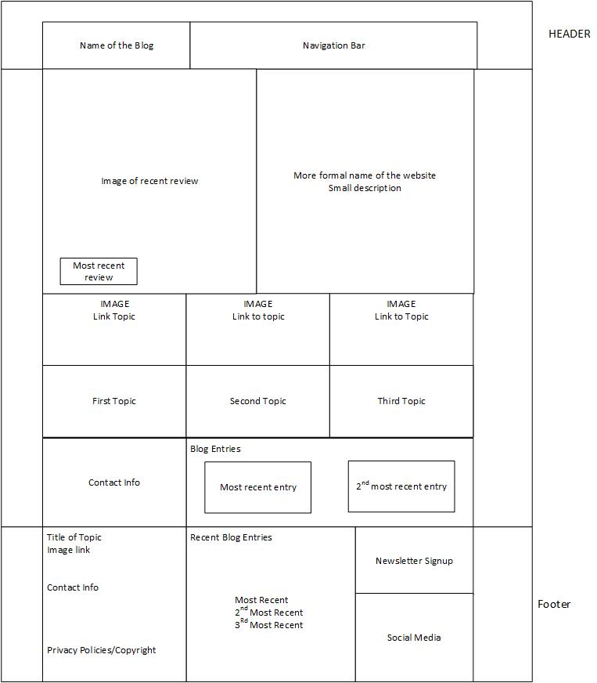

## Webpage Mockup:

This is a quick example of the website that we are developing.

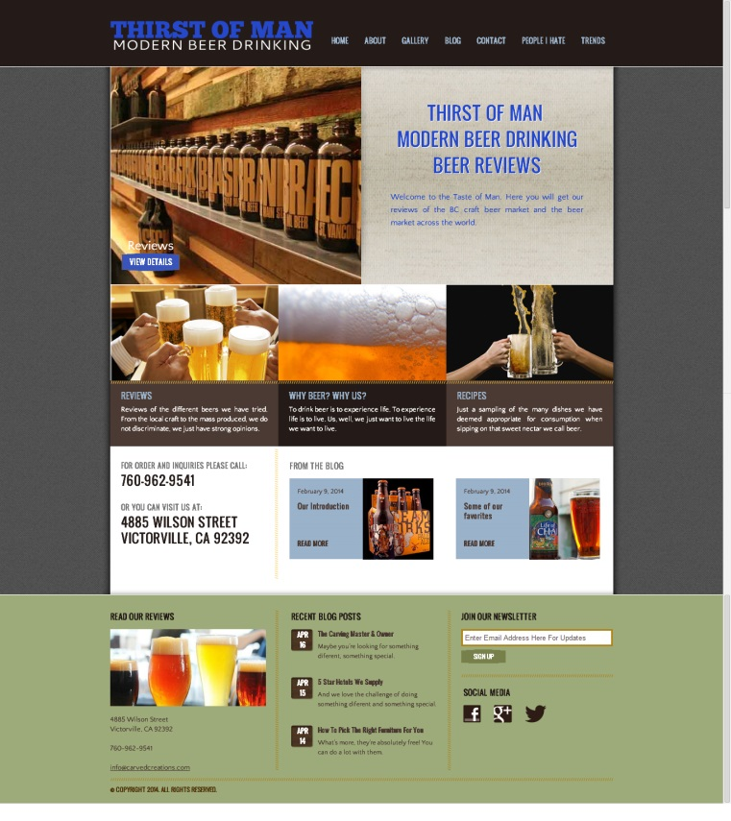

## Database Design:

